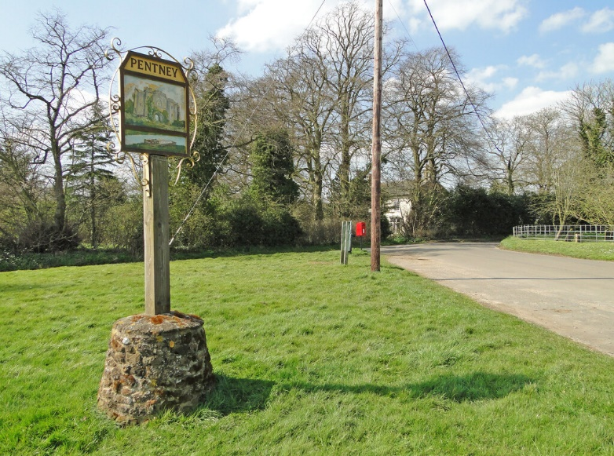

PENTNEY PARISH COUNCIL

Chairman Ben Howlett/Rosie Littlehales
Pentneyparishcouncil@gmail.com
Mobile: 07880 858008

Minutes of the Parish Council Meeting of Pentney Parish Council held on Wednesday 18th May 2022 at 7.30pm at the Village Hall.
Present: Cllr K Harvey, Cllr M Parker, Cllr L Rons, Cllr B Howlett, Cllr C Dallas, Cllr R Littlehales, J Howard (Clerk).

10 members of the public attended.

- Chair to welcome those in attendance.

Cllr Howlett welcomed everyone to the meeting

- To receive and consider apologies for absence.

Apologies from Cllr Patricia Wells who is on holiday

- To receive any declarations of interest from Members & consider requests for dispensation. Members are invited to declare disclosable pecuniary interests and other interests in items on the agenda as required by the Localism Act 2011.

No declarations of interest were submitted.

- Election of a new chair

Cllr Rosie Littlehales was proposed and elected to the position of Chair with a unanimous vote. Cllr Howlett stood down as Chair and Cllr Littlehales continued the meeting.

- Election of a vice chair

Cllr Michael Parker was proposed and elected to the position of vice Chair with a unanimous vote.

- Public Participation (10 mins). This provides an opportunity for members of the public to raise questions about and comment on items on the agenda, and other points, before the Council make decisions.

There were no questions raised during public participation.

- To approve the minutes of the Council meeting of Wednesday 6th April 2022

The minutes of the council meeting of 6th April were agreed and signed by Cllr Littlehales.

- To consider matters arising from the minutes of Wednesday 6th April 2022 for reference only.

There were no comments raised in relation to the minutes of Wednesday 6th April 2022.

- Matters Arising

a). To vote on a new dog bin on Pentney lane.

Following a request from Cllr Rons, the Council discussed and agreed to the purchase and installation of an additional Dog bin to be sited on Pentney lane.

Clerk to forward the quotes to Cllr Parker who agreed to assist with the fitting.
Clerk to organise purchase and delivery of the bin.

b). Update on notice board

After discussion it was agreed that the Clerk would get a locksmith to look at the Parish Notice board.

c). Update on defibrator training

Cllr Dallas updated the council on Defibrillator training which will now be in September/October in the Village Hall. The training is for 12 people.

d). Feedback on River Swan issues

Cllr Parker fed back on the river Swan which he has been monitoring. A resident reported that there was a terrible stench from the river although it looked clear.
Cllr Parker agreed to continue to monitor and discuss with the environmental officer. He will feed back at the next meeting.

e). Grass cutting contract

Concerns were raised regarding the CGM contract for grounds maintenance. Footpaths are not being cleared after grass cutting, the invoice doesn’t tally with the schedule and questions were raised in relation to the cutting schedule.
Clerk to contact CGM for clarification.

f). Highway and community Ranger visit

The community Rangers are due to visit in June. Councilors drew up a list of areas with potholes and requested that a councilor should accompany them when they visit.
Clerk to liaise with the Rangers
Cllrs to report any further issues to the Clerk

g). Update on Neighborhood plan

Deferred to point 10 e),

h). Narborough road culvert

The Clerk gave an update on the Culvert. We have provided everything that is
required for the culvert to progress and are now awaiting a start date.

10 To accept official reports

a). County Council.

Cllr Moriarty gave his apologies. His report was circulated to council members and will be attached to the minutes.

b). Borough Council.

Cllr Howland gave his apologies.

c). Parish Clerk d). Financial report

The clerk gave a short update on the transfer of our current account to
Unity trust and the transparency which we are now able to operate under.
There was a brief explanation of the audit process which the council is currently
undergoing.

e). Neighborhood plan

Cllr Littlehales gave an update on the neighborhood plan which has gone to Kings
Lynn for further consideration prior to consultation with outside bodies. She
discussed ways in which the public could view the document at the appropriate
time to ensure transparency with the process.

- To discuss any planning applications

Cllr Rons gave an update on the Pentney woods planning application which the
Parish Council had not been consulted on. The council was given a 21 day
consultancy period to comment. Comments are available on the
Kings Lynn planning website.

- To discuss plans for the Platinum Jubilee and Update and successful grant

Cllr Littlehales gave an update on the parish councils successful grant application
for a Jubilee celebration, which will include a tree planting in October. We are
making plans for the event which will be communicated to residents in the
coming weeks.

13 To agree to the signing and submitting of Section 2 of the AGAR certificate
of exemption.

(Section 2 of AGAR (Annual Governance and Accountability Return) allows
councils with an annual income and spend below £25000 pa to exempt
themselves from submitting for external audit. It requires a certificate of exemption
to be signed and submitted before the end of June. It still requires the internal
audit to be completed and the AGAR form to be filled in. It also requires the
notification to the public (in due course) of their rights to examine the accounts.)

Agreed and signed.

14 To confirm the date of the next Parish Council meeting as 29th June 22.

Confirmed.

